STANDARD OPERATING PROCEDURE
Created: Version No:

WORKING WITH LIVESTOCK SOP
Cattle armers are in very regular contact with livestock including dairy cows, bulls and calves. The risk of injury is high due to the potential for being crushed or kicked when in close proximity. Basic livestock handling knowledge and skills are necessary.
JOB STEPS | MEDIA | SAFETY / QUALITY / ENVIRONMENT
BASIC FACTS FOR DAIRY COWS:  Agitated cattle are a risk; make sure the whole cattle handling experience is a pleasant one for you and the cattle.  - Dairy cattle are usually docile and predictable but can change to become unpredictable quite quickly  - Most herds have a range of cattle with different behaviours, including docile, flighty, nervous and aggressive types  - Even docile animals can change temperament especially if stressed or isolated  - Cows with young calves can become aggressive  - Different breeds often have different temperaments  - Horned cattle increase the risk of injury  - Always move quietly and calmly around stock | 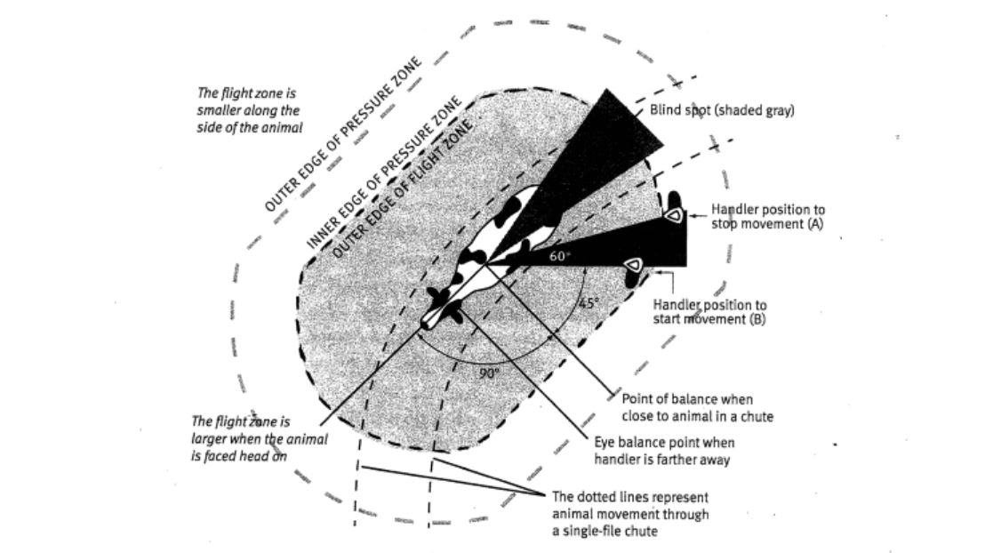 | Safety - Your actions can affect dairy cow behaviour  Remember:  - Know your cattle.  - Keep cattle calm.  - Assess the type of stock and their behaviour.  - Keep an eye on what’s going on around you.  - Know when to use your voice.  - Check the yards for hazards before working cattle  - Wear safety footwear.  NEVER:  - Handle cattle if you do not feel confident in handling them safely  - Stress or arouse cattle unnecessarily  - Turn you back on a cow when approaching and handling her calf  - Suddenly enter the animals 'Blind Spot'  - Rush into the animals 'Flight Zone'  - Beat or shout at cattle unnecessarily
BASIC FACTS FOR BULLS:  - Bulls are more unpredictable and dangerous than dairy cows  - Bulls are often more aggressive during mating season  - Bulls are extremely dangerous when fighting with other bulls  - The older the bull, the more dangerous it can become. | 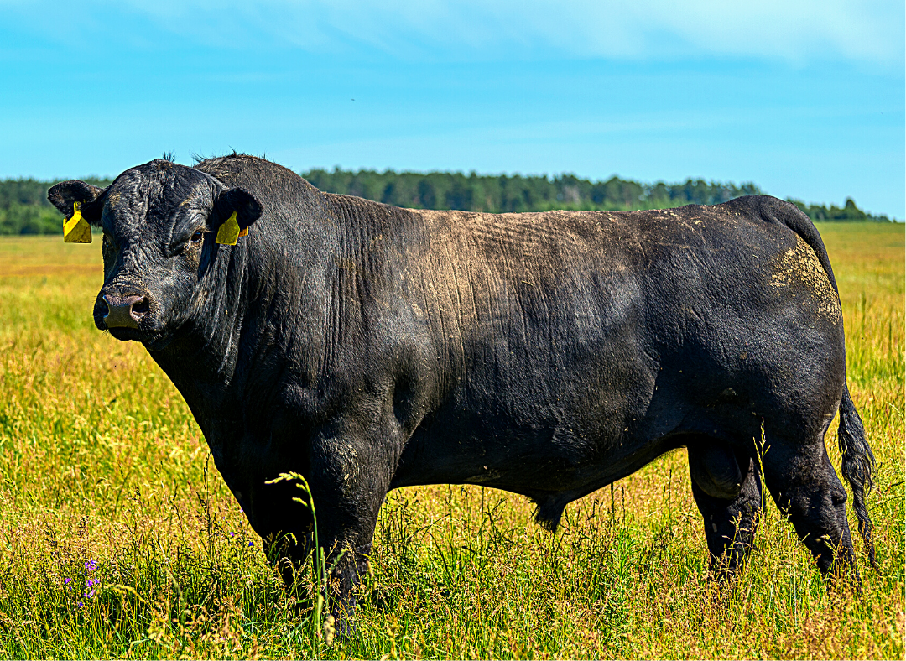 | Safety - a. Never trust or turn your back on a bull  b. Ensure two people are present when handling bulls  c. Avoid working bulls with other bulls around.  d Always work with bulls in the same yard and ensure they are excluded from dairy yards

WORKING WITH LIVESTOCK - V4
Cattle farmers are in very regular contact with livestock including dairy cows, bulls and calves. The risk of injury is high due to the potential for being crushed or kicked when in close proximity. Basic livestock handling knowledge and skills are necessary.
JOB STEPS | MEDIA | SAFETY / QUALITY / ENVIRONMENT
BASIC FACTS FOR CALVES:  - Calves weigh between 30-100kg, so can cause major safety issues for adults and children  - Any cow, but particularly a beef cow, is often aggressive just after calving and is not to be trusted.  - The younger the calf, the more dangerous the mother.  - Calves can kick, head-butt or knock over inexperienced handlers in their haste to be fed  - Calves can be responsible for disease transmission to humans. The possible zoonoses from calves include cryptosporidium, campylobacteriosis, salmonella and  E. coli | 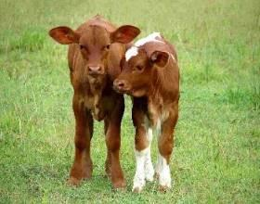 | Safety - a. Avoid lifting calves if possible as 30-100 kg poses a major manual handling risk in regard to back and shoulder injury. It is difficult to anticipate sudden changes in behavior when holding a calf.  b. Avoid situations where you come between a cow and her newborn calf without some form of barrier to protect yourself.  c.Always wash your hands after handling calves to prevent picking up an infection.
WORKING WITH CATTLE IN THE DAIRY:  Working with cattle in the dairy is a key role on the farm and must be undertaken with care. See the safety tips. | 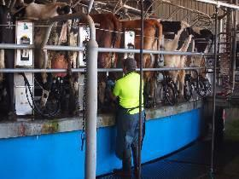 | Safety - NEVER:  - Put your head under a kick rail  - Put your arm between a rail and an animal (particularly kick rails in the dairy)  - Put your hand flat on the dairy platform  - Stand between a gate and a fence when holding the gate

