STANDARD OPERATING PROCEDURE
Created: Version No:

PADDOCK ROTATION BOARD AND PADDOCK SET UP TEMPLATE
Use this as a template to create and SOP for your farm - you can edit the tagged activities below.
JOB STEPS | MEDIA | SAFETY / QUALITY / ENVIRONMENT
PADDOCK ROTATION BOARD  - The board shows a table with an "AM" and a "PM" line for every herd. The columns show the day and the date.  - The gap between a day and the "AM"/ "PM" shows where the cows go on THAT day AFTER the "AM" or "PM" milking.  Example: AM, Tuesday the 1st of August, Paddock 5 1/3  That means on Tuesday the 1st of August, the cows will go to paddock 5 after milking but only get 1/3 of the paddock.  That means, the PM Jockey on that day will find the cows in Paddock 5. | 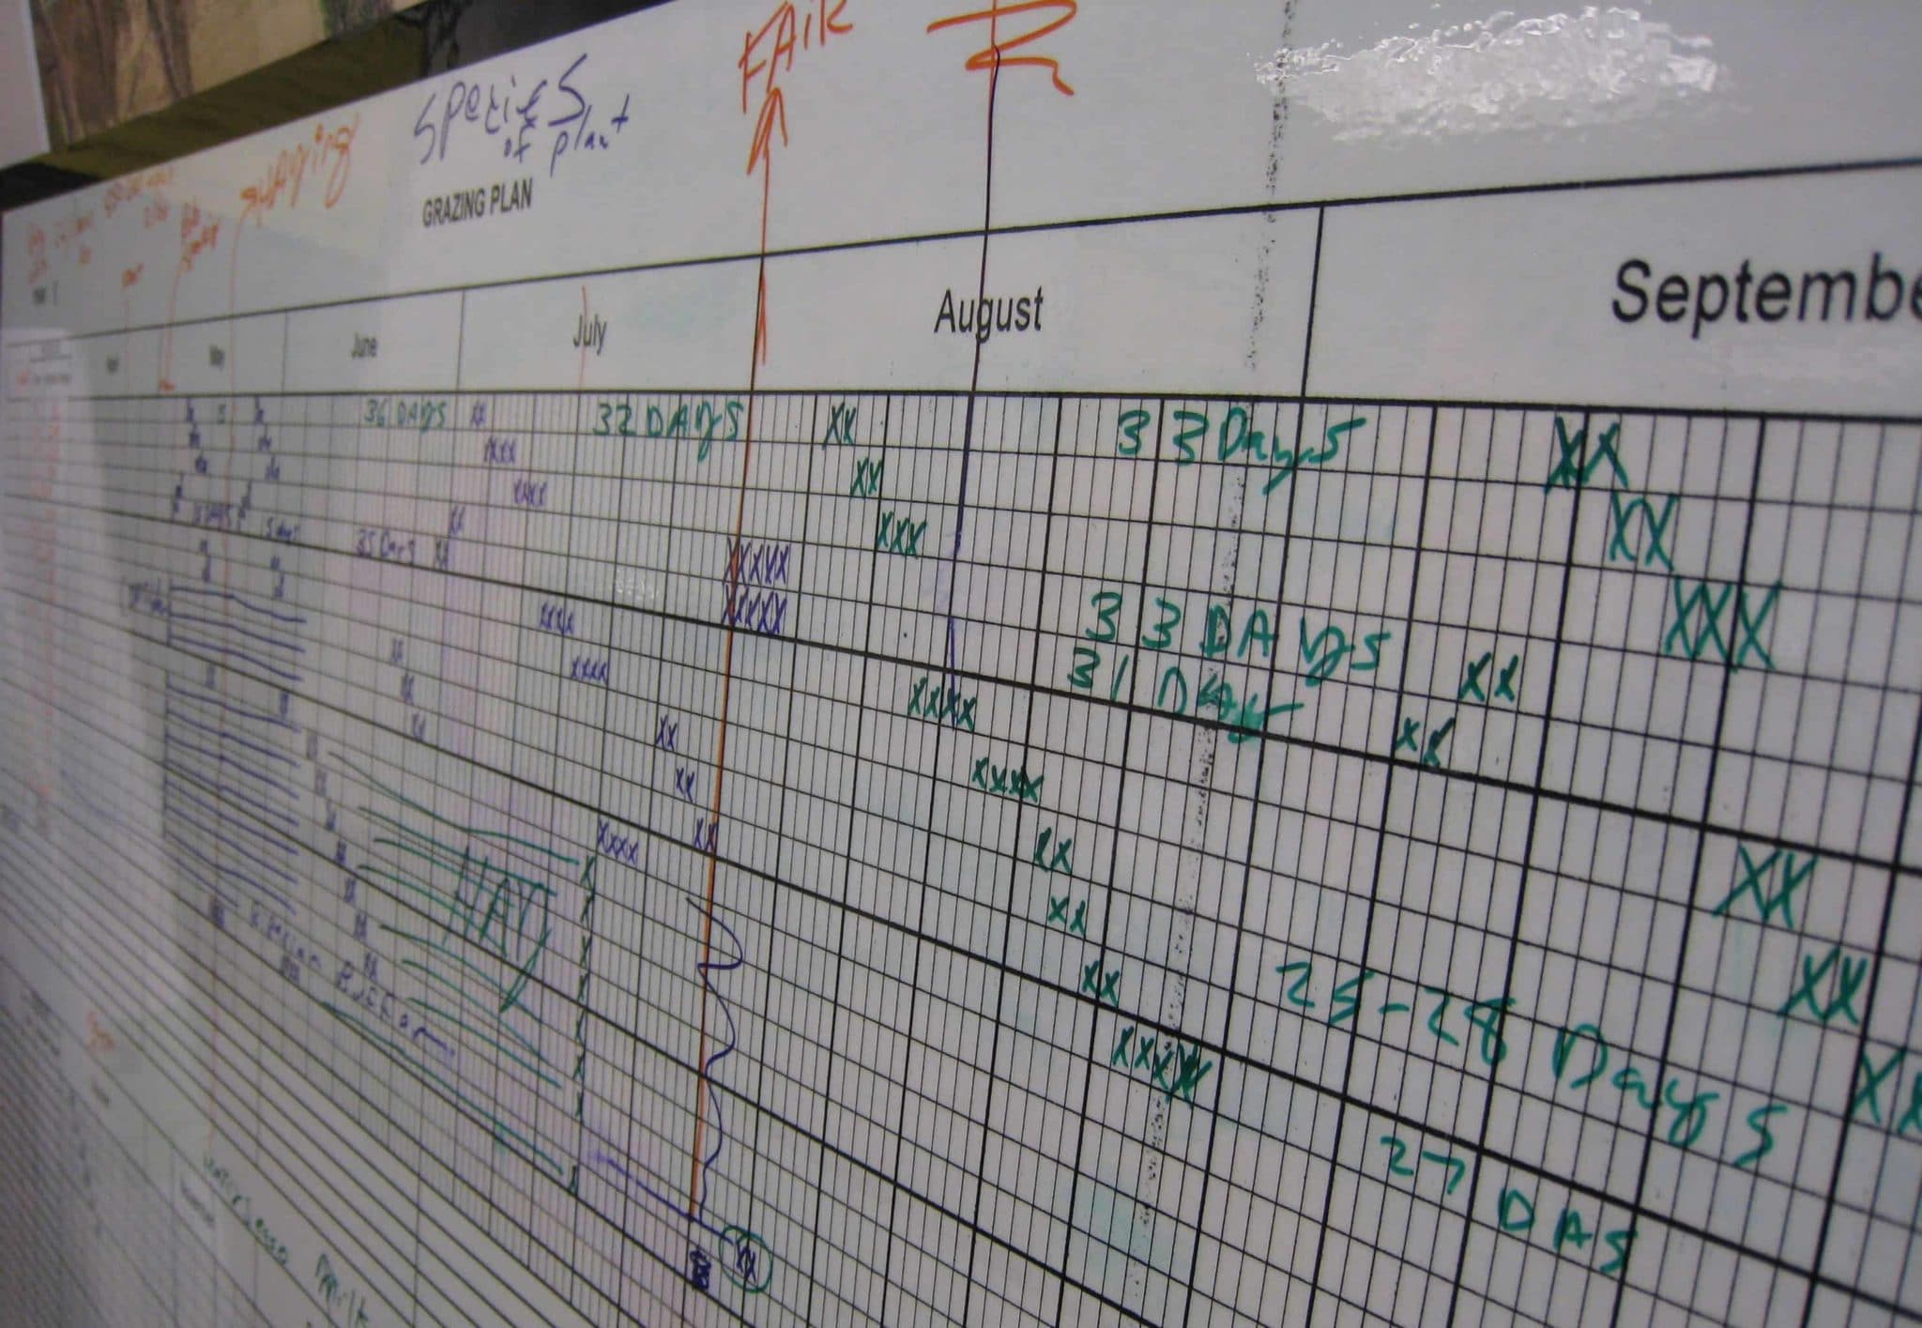 | Quality - Try to keep the Rotation Board as tidy as possible to prevent confusions.
FARM MAP  - You will find the farm map next to the Paddock Rotation Board in the office.  - Every paddock has a name/ number written on the inside.  - Lane ways and permanent fences are shown clearly. | 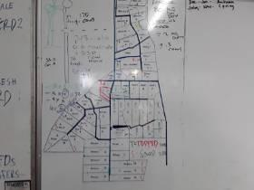 | Quality - Keep the map tidy so it is easy to understand for everyone.

PADDOCK ROTATION BOARD AND PADDOCK SET UP V2
Use this template to create and SOP for your farm - you can edit the tagged activities below.
JOB STEPS | MEDIA | SAFETY / QUALITY / ENVIRONMENT
SPLITTING A PADDOCK  - The Paddock Rotation Board shows you how much of a paddock the cows get.  - Drive along the fence towards the back and count the posts. If there is an area without grass (too dry, big puddle,...) this part does not count in your calculations.  - Check that the back gates of that paddock are shut.  - Divide the number of posts for example by 3 if the cows get 1/3 or by 2 if the cows get 1/2.  - If there is no water trough within the first part of the paddock, set the reel behind the water trough so the cows can access water.  - Hook the handle onto the fence on one side and drive slowly towards the other side holding the reel in your hand allowing the fence to unroll.  - Tighten the strip fence and attach it to the other permanent fence.  - Set pig tail posts to hold the strip fence up.  - Attach the fence to the power on one side of the paddock OR use a solar power box. | 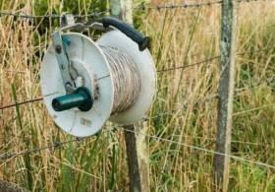 | Safety - Do not touch a powered fence.  Quality - The straighter the fence, the stronger.
Created: 22 April 2020 Version No: 1

