STANDARD OPERATING PROCEDURE
Created: Version No:

USING SIDE BY SIDE VEHICLES TEMPLATE
This SOP is to be followed whenever you are using a side by side (SBS) vehicle
JOB STEPS | MEDIA | SAFETY / QUALITY / ENVIRONMENT
DO NOT use this equipment unless you have been instructed in its safe use and operation.  Side by side vehicles rely on the use of seat belts and retention strapping / doors for safe use. Regularly check that these are in sound condition, and do not use the vehicle if maintenance is required. |  | Safety - • All users of this equipment must be trained and inducted into its use - a cursory instruction is not sufficient.  Records must be kept of the training, including the key elements of the instruction.  - When first purchasing Side By Side (SBS) vehicles, request a handover from the supplier. This should include safety information and manufacturer recommendations.  - All users must be given the opportunity to read and understand the instruction literature from the manufacturer.
PERSONAL PROTECTIVE EQUIPMENT  - Wear suitable clothing, typically including long trousers and boots.  - Wear sun protection as required.  - Wear sunglasses.  - Wear hearing protection for extended use, or otherwise as required.  - Assess risks and consider wearing an approved helmet. Helmets are recommended by some manufacturers. |  | Safety - Wearing suitable clothing and appropriate PPE is mandatory for all farm team members.

USING SIDE BY SIDE VEHICLES - V5
This SOP is to be followed whenever you are using a side by side (SBS) vehicle
JOB STEPS | MEDIA | SAFETY / QUALITY / ENVIRONMENT
PRE-START OPERATIONAL CHECKS  - Follow manufacturer’s recommendations and warning labels.  - Locate and ensure you are familiar with all machine operations and controls.  - Before starting the side-by-side, ensure all levers are in their neutral positions, the parking brake is engaged.  - Ensure you are trained and competent and if driving on public roads, and appropriately licensed. Use on public roads is not recommended.  - If the side-by-side is used on public roads, ensure all lights and warning devices are functioning and the vehicle is registered.  - Always tell someone where you are going and estimated time of return. | 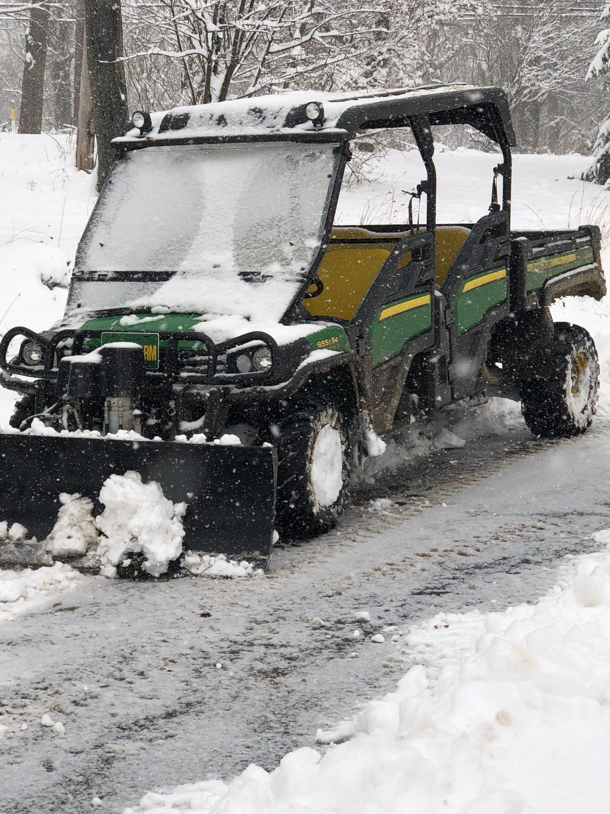 | Safety - Ensure all guards are fitted, secure and functional. Do not operate if guards are missing or faulty.  Ensure the seatbelt, roll over protective structure (ROPS), and guards are in sound condition.  Check tyre condition and pressures regularly  j. Use only implements that meet the manufacturer’s recommendations.  Environment - Familiarise yourself with the owners manual before use of the side by side
PRE-OPERATIONAL SAFETY CHECKS  - Do not carry more than the number of passengers that the vehicle has been designed for. Each occupant must wear a seat belt.  - Do not exceed the rated load capacity  - Ensure that loads are suitable and secured.  - Irrespective of the rated capacity, ensure a safe load by keeping the center of gravity low and ensuring the load cannot shift when underway.  - If towing, do not exceed rated tow capacity (for trailer and contents). Pull only from the supplied drawbar.  Do not use a side-by-side that is not in good repair. |  | Safety - • Do not use faulty equipment. Report suspect machinery immediately.  - Never start or operate levers from anywhere other than the seat.  - Do not dismount while the engine is running unless the side by side has completely stopped, the transmission is in park position and the parking brake is fully engaged.  - Observe speed limits and no-go areas.  - Drive at speed slow enough to keep control of unexpected hazards such as holes, stumps or undulations.  - Monitor traffic, and ensure no person or animal is endangered when operating equipment.

USING SIDE BY SIDE VEHICLES - V5
This SOP is to be followed whenever you are using a side by side (SBS) vehicle
JOB STEPS | MEDIA | SAFETY / QUALITY / ENVIRONMENT
ENDING OPERATIONS:

- Park on level ground.

- Lock the parking brake.

- Stop the engine and remove the keys
AFTER USE:  - Remove any foreign material from in and around engine and implement parts.  - Check for damage and report if found  - Clear foot control area of any debris. |  | Safety - If there are any safety or operational maintenance issues, take the machine out of service until these are addressed. This can be done by isolating the keys if necessary.
Created: 11 March 2021 Version No: 1

