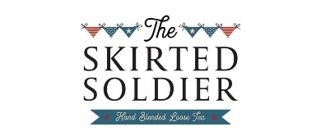
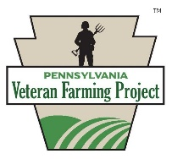
PA Veteran Farming Project 2020 Mini-grant Program

With generous funding from Air Force woman veteran-owned The Skirted Soldier, female veterans residing in Pennsylvania are invited to compete for a $1000 mini-grant for improvements on their farm or agribusiness, marketing (signage, logo or web design, etc.), or other items that will improve the economic viability of their farm operations.
Eligibility: Female US veterans who have owned or operated a farm or agribusiness in Pennsylvania for
at least 2 years.
1. Grant funds will be made paid to applicant’s preferred vendor, not to individual recipient.
2. Applicant must provide proof of honorable service with application.
3. Farm or agribusiness must be 50% or more woman-veteran owned.
4. Applicant agrees to a site visit by a member of grant committee if requested.
5. Awardee agrees to provide photograph(s) of the purchased item(s) on site, including at least one
with the awardee in the photo.
6. Applications must be received by 5 pm EST Monday, February 10, 2020. Hard copy applications must include copy of proof of service (DD-214; DD 256, NGB 22, VIC, VA Healthcare card, Homegrown by Heroes membership documentation: redact birthday and all but last 4 of SSN). Mail to: PAVFP, PO Box 65, Forbes Road PA 15633.
_______________________________________________________________________________
All fields required. Use as much space as necessary to provide the reviewers a full picture of your project. You may include photos if you wish.
Name
Farm/Agribusiness Name
Address
Phone
Email
Website
Social media url(s)
Describe your project—what will you purchase if awarded the grant?

How will your project impact the life of your farm or business?
Please tell us a little about your military service.
If you receive the grant, how will you measure the success of your project?
Is there anything else you’d like the application review committee to know?

